GCSE Psychology – ‘Do Now’ Retrieval Practice Starters

Development

Name: ________________________________

- Outline of early brain development
Add description about 4 key parts of the brain already labelled below.

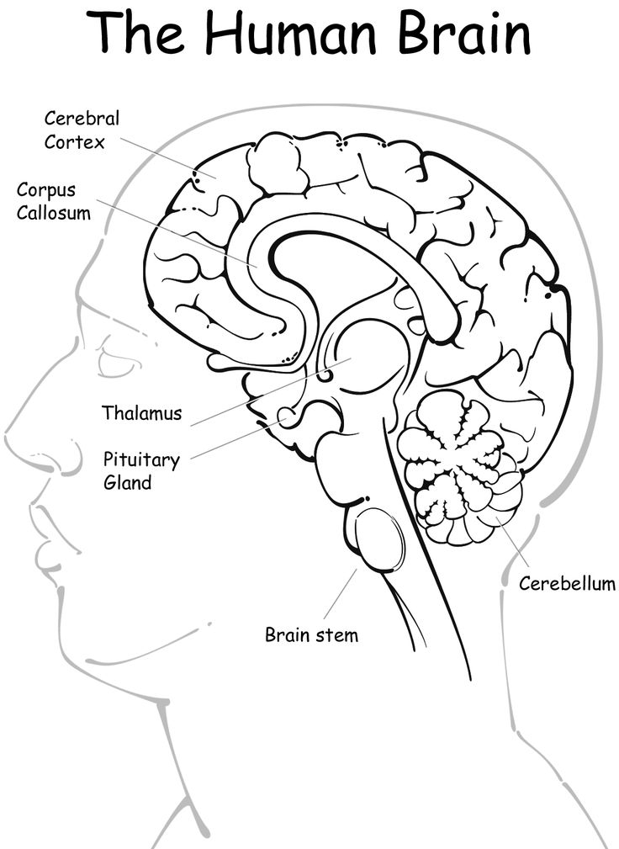

- The roles of nature and nurture
What is nature? | What is nurture?
Do the two interact?

How do the below things affect the growing brain?
Smoking | Infection | Voices
- Piaget’s theory
- What does cognitive development mean?

- What is a schema?

- What is assimilation?

- What is accommodation?

- Evaluating Piaget’s theory
 | Point | Evidence | Explanation
Strength
Weakness
- Stages of cognitive development
Stage | Age | Key characteristics
 | 0-2
Pre-operational
 | 7-11
 |  | Formal reasoning – able to deal with hypothetical ideas and abstract thinking.

- Evaluating the stages of cognitive development
 | Point | Evidence | Explanation
Strength
Weakness
- Piaget’s study of conservation
- What is conservation?

- At what age/stage did Piaget suggest children are able to conserve?

Explain what is happening in each of the images below.

- McGarrigle and Donaldson’s ‘naughty teddy study’
Conclusions:
Results:
Aim:

- Evaluating McGarrigle and Donaldson’s ‘naughty teddy study’
 | Point | Evidence | Explanation
Strength
Weakness

- Piaget’s study of egocentrism
- What is egocentrism?

- At what age/stage did Piaget suggest children are no longer egocentric?

Explain Piaget’s three mountain task.
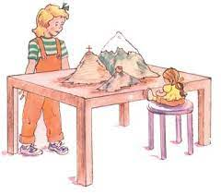
____________________________________________________________
____________________________________________________________
____________________________________________________________
____________________________________________________________
____________________________________________________________
____________________________________________________________

- Hughes ‘policeman doll study’
Results:
Aim:
Conclusions:

- Evaluating Hughes ‘policeman doll study’

 | Point | Evidence | Explanation
Strength
Weakness

- Application of Piaget’s theory to education
Link to the stages…
Sensorimotor
Pre-operational
Concrete operational
Formal operational

- Evaluating the application to education
 | Point | Evidence | Explanation
Strength
Weakness
- Dweck’s mindset theory of learning
- What is a growth mind-set?

- What is a fixed mind-set?

- How would someone with a fixed mind-set deal with failure?

- Evaluating Dweck’s mindset theory of learning
 | Point | Evidence | Explanation
Strength
Weakness

- The role of praise and self-efficacy
- How does praise affect development?

- Why should effort be praised rather than performance?

- How does self-efficacy affect development?

- Evaluating the role of praise and self-efficacy
 | Point | Evidence | Explanation
Strength
Weakness

- Learning styles

- Evaluating learning styles
 | Point | Evidence | Explanation
Strength
Weakness

- Willingham’s learning theory
- What does Willingham think of learning styles and why?

- Why does Lepper et al. suggest praise should be unexpected?

- What does Willingham suggest you need to help you with remembering something?

- How could people with a learning difficulty e.g. dyslexia be supported?

- Evaluating Willingham’s learning theory
 | Point | Evidence | Explanation
Strength
Weakness

