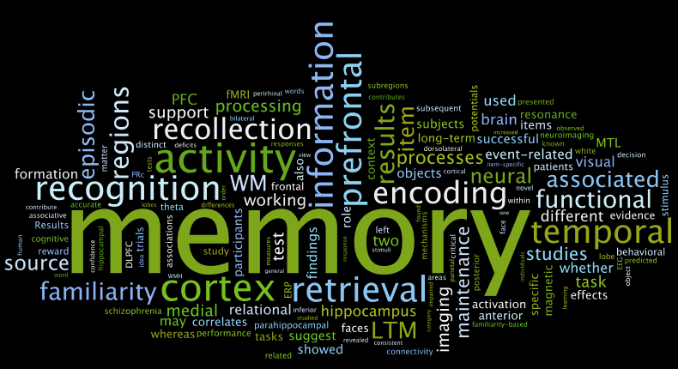

|  |  |  |  |  |  |
| --- | --- | --- | --- | --- | --- |
|  | Notes made in my book (Yes or No) | Covered it in class but need some help | I understand this | I can talk/write about this without notes | I have revision notes for this, and I am exam ready! |
| I can define encoding, storage and retrieval and use examples. |  |  |  |  |  |
| I can explain how memories are encoded and stored using examples. |  |  |  |  |  |
| I can describe episodic, semantic and procedural memory and use examples. |  |  |  |  |  |
| I can describe the multi-store model of memory including the sensory, short term and long-term stores. |  |  |  |  |  |
| I know the features of each store of the multi-store model of memory including coding, capacity and duration. |  |  |  |  |  |
| I can explain the effects of serial position such as primacy and recency effects. |  |  |  |  |  |
| I can describe and evaluate Murdock’s serial position curve study. |  |  |  |  |  |
| I can describe the theory of reconstructive memory- including the concept of ‘effort after meaning’. |  |  |  |  |  |
| I can describe and evaluate Bartlett’s war of the ghosts study. |  |  |  |  |  |
| I can explain factors that affect the accuracy of memory including interference, context and false memories. |  |  |  |  |  |