Psychological problems 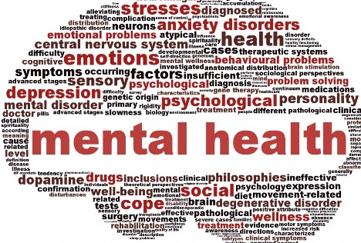
 | Notes made in my book (Yes or No) | Covered it in class but need some help | I understand this | I can talk/write about this without notes | I have revision notes for this, and I am exam ready!
Characteristics of mental health
How mental health has changed over time
Cultural variations
Increased challenges of modern living
Increased recognition and lessening of social stigma
Effects of mental health on individuals
Effects of mental health on society
Characteristics of clinical depression including the use of ICD
Theories of depression – biological explanation
Theories of depression – psychological explanation
Therapies for depression – use of antidepressant
Therapies for depression – CBT
Wiles’ study of the effectiveness of CBT
Characteristics of addiction
Theories of addiction – biological explanation
Theories of addiction – psychological explanation
Therapies of addiction – aversion therapy
Therapies of addiction – self-management programmes

