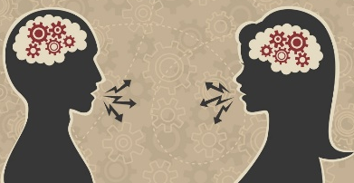
Language, thought and communication
 | Notes made in my book (Yes or No) | Covered it in class but need some help | I understand this | I can talk/write about this without notes | I have revision notes for this, and I am exam ready!
Piaget’s theory: Language depends on thought.
The Sapir-Whorf hypothesis: Thinking depends on language.
The effect of language and thought on our view of the world - Variation in recall of events and recognition of colours.
Differences between human and animal communication - Von Frisch’s bee study
Differences between human and animal communication - Limited functions and properties of human communication not found in animal communication.
Non-verbal communication - Functions of eye contact including regulating flow of conversation, signalling attraction and expressing emotion.
Non-verbal communication - Body language including open and closed posture, postural echo and touch.
Non-verbal communication - Personal space including cultural, status and gender differences
Explanations of non-verbal behaviour - Darwin’s evolutionary theory of non-verbal communication as evolved and adaptive.
Explanations of non-verbal behaviour - Evidence that non-verbal behaviour is innate, eg in neonates and the sensory deprived.
Explanations of non-verbal behaviour - Evidence that non-verbal behaviour is learned. Yuki’s study of emoticons.

