**Rushden Academy**

Edexcel

A Level History

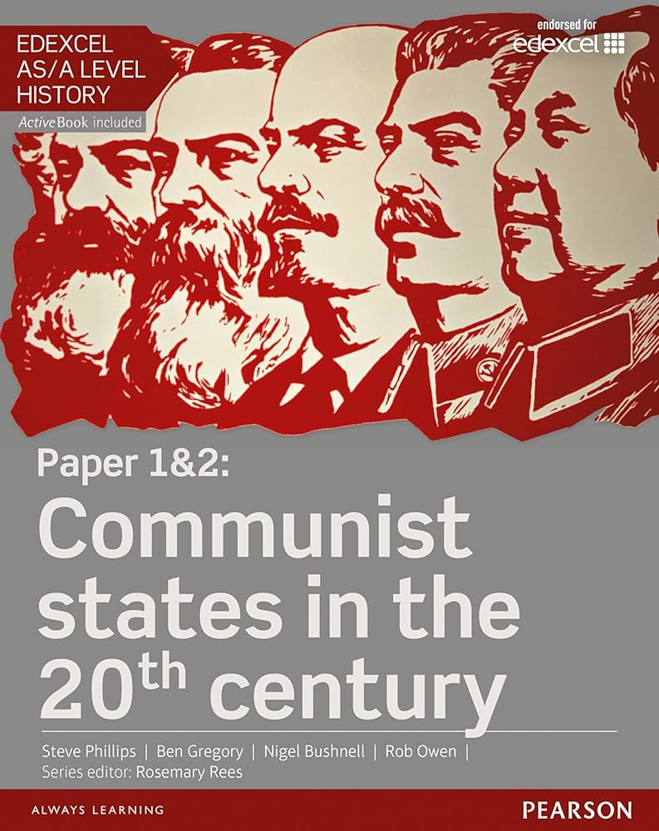

Beginning your A Level Journey

**Year 12 Summer Booklet**

Name:

**A Level History Summer Tasks Booklet**

Instructions:

This booklet contains clear information about starting this A level. Please read it carefully before starting in September.

Please complete all of the tasks set in this booklet before beginning your A-Level History course in September.

Before joining the course officially, this book must be totally completed and handed in on your first day.

Failure to complete this booklet will result in your being sent away from your first History lesson.

The booklet is divided into two sections- Russia: From Lenin to Yeltsin and The German Democratic Republic

Any questions/ problems, please email :[g.oddy@rushden-academy.net](mailto:g.oddy@rushden-academy.net)

**Russia 1917-1991: Lenin to Yeltsin - Summer Task**

*Task 1: Find definitions of the following words and write them below:*

* Lenin:
* Stalin:
* February Revolution of 1917:
* October Revolution of 1917:
* Communism:
* Bolshevism:
* Tsarism:
* Autocracy:
* Tsar Nicholas II:
* Regime:
* Coup:
* Soviet Union / USSR;
* Provisional Government;
* Duma:
* Petrograd Soviet:
* Karl Marx:
* Civil War:
* One Party State:
* Bourgeoisie:
* Proletariat:
* Dictatorship of the Proletariat:

**Russia 1917-1991: Lenin to Yeltsin - Summer Task**

*Task 2: Read the article below and make a mind map of Lenin’s qualities as a leader.*



**Russia 1917-1991: Lenin to Yeltsin - Summer Task**

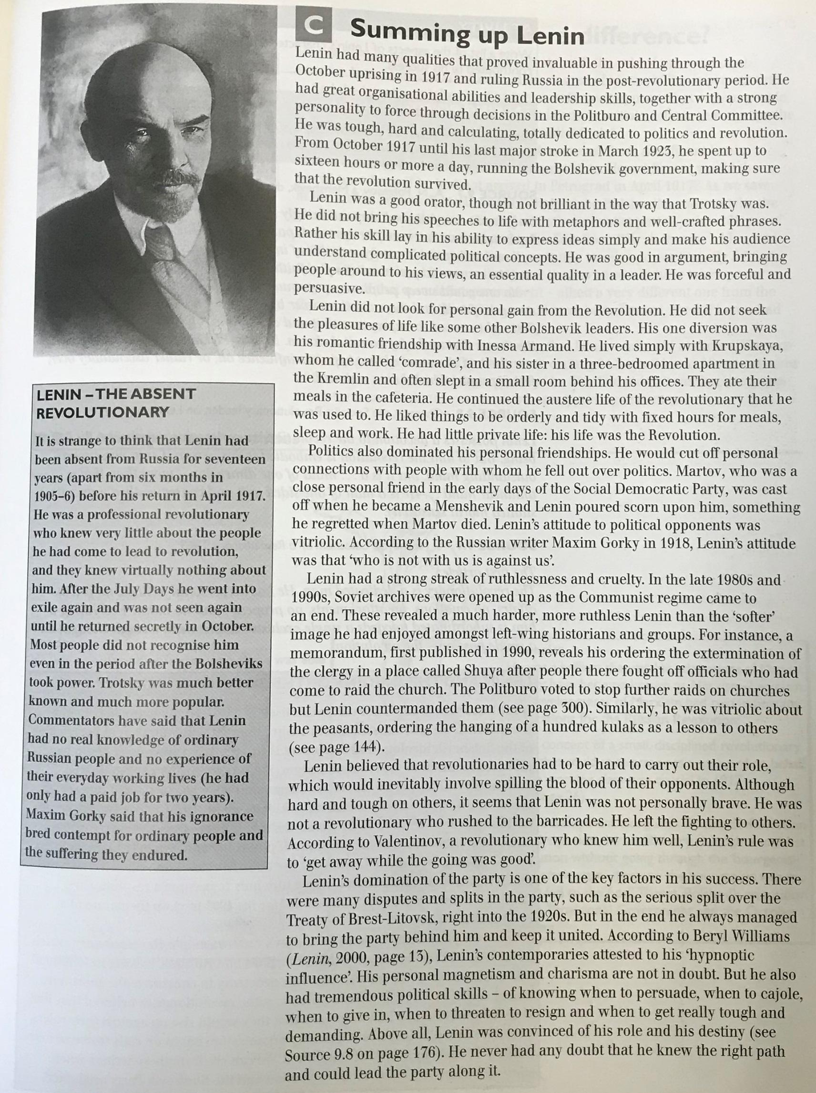

**Russia 1917-1991: Lenin to Yeltsin - Summer Task**

*Task 3: Answer the following questions below in full sentences:*

1. What do you think was the most important quality in making Lenin a strong leader? Why?
2. What is meant by the phrase “the absent revolutionary”?
3. How did the way historians remember Lenin’s legacy change in the late 1980s and 1990s? Why?
4. Make a list of any words / phrases you did not understand and find the definitions to them.

**German Democratic Republic 1945-1990 - Summer Task**

*Task 1: Find definitions of the following words and write them below:*

* GDR:
* FRG:
* SED:
* USSR:
* Class struggle:
* Stasi:
* Eastern Bloc:
* Ulbricht group:
* Third Reich:
* Democratic centralism:
* Nationalism:
* Centralised planned economy:
* Stalinallee:
* Junker:
* Collectivisation:
* Consumer socialism:
* Détente:
* Prefabricated:
* Grundshule:
* Propaganda:
* Censorship:
* Niche Society:

**German Democratic Republic 1945-1990 - Summer Task**

*Task 2: Read and annotate these sources/interpretations:*

***Interpretation 1) By John Simkin (john@spartacus-educational.com) © September 1997 (updated August 2014).***

The German Democratic Republic (East Germany) was established in 1949 from the area of Germany occupied by the Soviet Union. East Berlin became the capital of the new country. As West Berlin remained part of the Federal Republic of Germany (West Germany) the capital was the cause of great conflict.

The main political figure in the German Democratic Republic was Walter Ulbricht who served as General Secretary of the Socialist Unity Party (1946-1971) and Chairman of the Council of State (1960-1971).

On 7th June, 1953, hundreds of thousands took to the streets of East Germany in demonstrations which began as a protest against increased work quotas and spiralled into demands for free elections. Red Army tanks were brought in and the Soviet military commander declared a state of emergency. More than 50 people were killed. Of these, about 20 of were executed, while more than 1,000 were convicted in the East German courts of having taking part in an "attempted fascist coup".

In 1955 the government of East Germany signed the Warsaw Treaty of Friendship Cooperation and Mutual Assistance with Albania, Bulgaria, Czechoslovakia, Hungary, Poland, Romania and the Soviet Union. The Warsaw Pact was created in response to the decision to allow the Federal Republic of Germany (West Germany) to join the North Atlantic Treaty Organization (NATO).

In the fifteen years following the Second World War over 3 million people emigrated from the German Democratic Republic to Federal Republic of Germany. In August 1961 the Berlin Wall was built to stem this flow of refugees.

In 1966 Willy Brandt became Foreign Minister in the Federal Republic of Germany (West Germany). He developed the policy of Ostpolitik (reconciliation between eastern and western Europe). In 1969 Brandt became Chancellor of West Germany. He continued with his policy of Ostpolitik and in 1970 negotiated an agreement with the Soviet Union accepting the frontiers of Berlin. He also signed the Basic Treaty with the German Democratic Republic.

In 1972 the German Democratic Republic was admitted to the United Nations. With the collapse of communism in 1989 the two German republics were united.

***Source 1) Waltraut Krugler, quoted by Hubertus Knabe in his book 17th June 1953: A German Uprising (2003)***

The street was full of people, saying 'come with us, do this with us'," she remembered. "At 2 o'clock in the afternoon, the street was black with people. The police said: 'All of you go home, and we will fulfil your demands.' But people shouted at the police and threw stones. Then the tanks came and people were killed.

***Source 2) An East German joke about Walter Ulbricht and Willy Brandt told during the 1970s.***

'Have you a hobby, Herr Brandt?'

'Yes, I collect jokes that people tell about me,' says Brandt. 'And you?' 'Oh, I collect people who tell jokes about me,' says Ulbricht.

***Source 3) An East German joke about Walter Ulbricht told during the 1970s.***

The Interior Minister telephones Walter Ulbricht. 'Thieves have broken into the Ministry this evening.' 'Have they stolen something?'

'Alas, yes. All the results of the next elections.'

***Source 4) An East German joke that circulated in the 1970s.***

A West German Communist was travelling on a train through the GDR. He got into a conversation with an old lady.

'Back home in West Germany,' he told her, 'shirts cost forty marks each.' 'Shirts?' said the old lady ruefully. 'We had those here once.'

'Butter is terribly expensive in the West. We are forced to eat margarine,' he continued. 'Yes,' said the old lady, 'we had margarine here once, too.'

'Now look here!' shouted the West German, by now thoroughly exasperated, 'You don't have to tell me these fairy-stories, you know! I'm a Communist!'

'A Communist?' sighed the old lady. 'Yes, we had those here once, too.'

***Source 5) Jeevan Vasagar, The Guardian (17th June, 2003)***

A German historian has accused the British of "betraying" an anti-communist uprising in the early years of the German Democratic Republic which was eventually put down by Soviet tanks. In a book published to coincide with today's 50th anniversary of the uprising, Hubertus Knabe claims that the western powers, in particular Britain led by Winston Churchill, declined to intervene because they feared a reunited Germany. Churchill rebuked a British commander who protested about the execution of a west Berlin student caught in the east and praised the Russians for their restraint. Mr Knabe, author of 17th June 1953: A German Uprising, said: "The demonstrators were bitterly disappointed, after the west's rhetoric about the liberation of Europe, and the encouragement of resistance, that when they went out on the streets, they received no support"

The anniversary has been trailed for weeks by political debates, television documentaries and theatre productions. In his book, the historian quotes Churchill expressing surprise that the British commander should have issued a complaint to the Russians without consulting London.The then prime minister asked whether the Soviet Union should have allowed "the eastern zone to collapse into anarchy and revolt", according to a private message quoted by Mr Knabe, and went on: "I had the impression that the unrest was handled with remarkable restraint."The west feared reunification. The foreign secretary, Selwyn Lloyd, told Churchill in a memo on June 22 that the allies felt "a divided Germany is safer at present. But none of us dare say so in public because of the impact on public opinion in Germany". The first East Germans to go out on the streets in 1953 were construction workers on Stalinallee, the Communist-era highway that slices through East Berlin.

**German Democratic Republic 1945-1990 - Summer Task**

*Task 3: Answer these questions based on the sources/interpretations:*

1. Using your previous knowledge of the Cold War and the information in this article- What was the Warsaw Pact and why was it set up in 1955?
2. Please create a mini character profile of Walter Ulbricht below including his years in office, his main political beliefs and any flashpoints during his career:
3. Describe the key features of Ostpolitik:
4. Study primary source number 3- what is the key message of this joke?
5. Study primary source number 5- According to the historian, why would Churchill ‘fear a reunited Germany.’?

**Course overview timeline - Summer Task**

*Task :Complete the Questions highlighted in yellow*

| **Germany** | **Date** | **World** | **Russia** | | |
| --- | --- | --- | --- | --- | --- |
| * *1871 Unification of Germany* | 1871 |  |  | | |
| * *1871–1918: German Reich (German Empire)*   *1. Who was leader of Germany at the outbreak of WW1?* |
| 1914 | Start of First World War |
| 1917 |  | * *February revolution*   *2. Who was overthrown in Feb 1917? Abdication of Tsar*   * *Return of Lenin: April Theses*   *3. What did Lenin promise in his Theses?*   * *Provisional government set up* * *October: Bolshevik seizure of power Constituent Assembly Elections Cheka founded* | | |
| 1918 | End of First World War | Bolsheviks disbanded Constituent Assembly  Treaty of Brest-Litovsk | 1918–20: Russian Civil War  4.Who was on each side?  1918–20: Allied intervention | 1918–21:  War Communism |
| *1919–33: Weimar Republic*  *5. List 5 features of the Weimar Republic.* | 1919 |  |  |
| 1920 |
| 1921 | Kronstadt Rebellion  Tenth Party Congress – ban on factions | 1921–22: Famine |
| 1921–28:  New Economic Policy  6. What was the New Economic Policy? |
| 1922 | Cheka renamed as GPU  Stalin became General Secretary of the Central Committee  USSR established |
| 1923 | ‘Scissors Crisis’ |  |
| 1924 | Lenin’s death  USSR constitution agreed |
| 1926 | Attacks began on Stalin’s political  opponents |
| 1927 | Grain shortages  Fifteenth Party Congress decided on industrialisation |

| **Germany** | **Date** | **World** | **Russia** | | |
| --- | --- | --- | --- | --- | --- |
| *1919–33: Weimar Republic* | 1928 |  | Grain requisitioning introduced. Shakhty trial |  | 1928–32: First Five Year Plan, focused on heavy industry  8. What are five year plans? |
| 1929 | Wall Street Crash | Defeat of the Right Opposition | Collectivisation of agriculture began |
| 1930 |  | 1930–31: First show trials took place  7 What are show trials? |  |
| 1931 |
| 1932 |  |  | 1932–33: The  Holodomor: severe famine in the Ukraine. |
| 1933 | 1933–37: Second Five Year Plan |
| *1933–45 Third Reich (Nazi Germany)*  *9. List 5 features of the Third Reich* |
| 1934 | Assassination of Kirov Seventeenth Party Congress  Congress of Writers adopted principles of ‘socialist realism’ | 1934–38: Purges |
| 1935 | Comintern adopted ‘popular front’ policy of cooperating with socialists abroad |
| 1936 | New constitution Trial of the Sixteen  Yezhov replaced Yagoda as head of NKVD |
| 1937 | Red Army purged  Trial of the Seventeen | 1937–38:  The Yezhovshchina |
| 1938 | Trial of the Twenty One  Beria replaced Yezhov as head of NKVD |  |
| 1939 | Start of the Second World War | Molotov-Ribbentrop Pact  10. What is the Molotov- Ribbentrop Pact |  | Only 16 of the 71  1934 Central Committee  members were still alive |
| 1940 |  | USSR annexed Estonia, Latvia and Lithuania  Trotsky assassinated in Mexico |  |
| 1941 | Germany invaded Soviet Union | 1941–44:  Siege of Leningrad |
| 1942 |  | 1942–33: Battle of Stalingrad |
| 1943 |
| 1944 |  |
| 1945 | Yalta Conference  End of Second World War |  |  |  |
| Division of Germany into four occupation zones  11. Who controlled each zone? | Potsdam Conference |
| Creation of SED  12. Who are the SED? | 1946 |  | Zhdanov launched attacks on cultural dissent |

| **Germany (from 1949–90 the GDR)** | |  | **World** | **Russia** | | |
| --- | --- | --- | --- | --- | --- | --- |
|  | | 1947 | Truman Doctrine and Marshall Plan |  |  |  |
| Berlin Blockade | | 1948 |  |
| End of Berlin Blockade Creation of GDR | | 1949 | NATO formed | COMECON formed Leningrad Party purged |  |  |
| GDR joined COMECON 13. What is Comecon?  Stasi (Ministry for State Security) formed  14. What role did the Stasi play in the GDR? | | 1950 |  |  |
| People’s Police increased to 50,000 | 1951-55: First Five-Year Plan | 1951 |
| ‘Stalin Note’ proposing a reunified and  neutral Germany  15. What does Stalin’s note tell us about his intentions regarding Germany?  Collectivisation of agriculture began SED announced the ‘building of socialism’ in the GDR  Five Länder replaced with 14 districts First elections to the GDR parliament | 1952 | Party renamed the Communist Party of the Soviet Union (CPSU) |
| The rising of June 1953 was suppressed by force 16. Who was  rebelling and why? | 1953 | Death of Stalin and succession of Beria |
| *Jugendweihe (secular youth ceremony, like confirmation) introduced as part of SED campaign against the churches* | 1954 |  | 1954–60: Virgin Lands Scheme |
| Warsaw Pact founded, with the GDR as  a member 17. List 3 features of the Warsaw Pact | 1955 | Khrushchev comes to power Warsaw Pact |
| National People’s Army (NVA) founded Ulbricht made concessions to head off threats to his position following  Khrushchev’s secret speech | 1956–60:  Second Five- Year Plan | 1956 | 1956: Hungarian revolution | Khrushchev’s Secret Speech to the  Twentieth Party Congress  18. What was the contents of the secret speech? |
| Erich Mielke became head of the Stasi (until 1989)  First Trabant P50 produced 19. What is a trabant? | 1957 |  | Khrushchev survived attempt of  ‘anti-party group’ to depose him |
| Khrushchev issued ultimatum over Berlin  Fifth SED Party conference | 1958 |  |
| Seven-Year Plan begun (to 1965) | 1959 |
| Pace of collectivisation increased President Wilhelm Pieck died and was  replaced by the Council of State (a collective head of state) | 1960 | U2 spy plane shot down |

| **Germany (from 1949–90 the GDR)** |  | **World** | **Russia** | | |
| --- | --- | --- | --- | --- | --- |
| Berlin Wall erected  20. Find five interesting Berlin Wall statistics | 1961 |  | Yuri Gagarin was the first man in space  Twenty-second Party Congress initiates further phase of de- Stalinisation |  |  |
| Compulsory conscription | 1962 | Cuban Missile Crisis |  |
| New Economic System introduced  Günter Mittag appointed Head of the Office for Economic Planning | 1963 |  |
| Alternative military service as construction workers (Bausoldaten) without bearing weapons introduced More open youth policy; new radio station DT 64 proved  popular with young people | 1964 | Fall of Khrushchev |
| Cultural reforms announced in 1963 reversed | 1965 |  |
|  | 1966 | Sinyavski-Daniel trial 21. Who as on trial and why? |
| 1967 | 1967–82: Andropov’s suppression of  dissidents |
| New constitution confirmed leading role of the SED | 1968 | Prague Spring Rebellion in Czechoslovakia |
| FRG Chancellor Brandt introduced Ostpolitik 22. Define Ostpolitik | 1969 |  |
| Meetings between FRG and GDR leaders End of New Economic System | 1970 |
| Ulbricht replaced by Honecker as SED leader  Four Powers’ Agreement on Berlin signed 23. 23. Find 3 interesting facts about Honecker | 1971 |
| Basic Treaty between FRG and GDR signed Nationalisation of virtually all remaining private enterprises | 1972 |
| First ‘oil shock’ as OPEC countries raise prices  Housing programme launched | 1973 |
| GDR revised its constitution to define itself as ‘A Socialist  State of Workers and Farmers’ rather than a ‘Socialist State of the German nation’ | 1974 | Solzhenitsyn  expelled from the Soviet Union |
| Helsinki Final Act agreed | 1975 | Vietnam War ends |  |
| Wolf Biermann exiled  New social welfare measures to benefit those with young families | 1976 |  |
|  | 1977 | Brezhnev’s Constitution: Article 6 confirmed the  ‘leading role’ of the Communist Party in the political system |
| Church-state agreement  Sigmund Jähn was first German in space | 1978 |  |  |

| **Germany (from 1949–90 the GDR)** |  | **World** | **Russia** | | |
| --- | --- | --- | --- | --- | --- |
| Second ‘oil shock’  Stasi grows to 80,000 | 1979 |  |  |  |  |
| Church Peace Movement formed | 1980 | Reagan became President of USA  Solidarity Movement in Poland |
| USSR cuts oil exports to the GDR  FRG Chancellor Schmidt visited the GDR | 1981 | Martial Law imposed in Poland |
|  | 1982 |  |
|  | Brezhnev died and was succeeded by Andropov |
| Josef Strauss arranged loans from the FRG | 1983 |  |
| Honecker’s planned visit to the FRG cancelled | 1984 | Andropov died and was succeeded by Chernenko |
|  | 1985 | Chernenko died and was succeeded by Gorbachev 24. Find 3 interesting facts about Gorbachev |
|  | 1986 | Gorbachev criticises Brezhnev era at Twenty-seventh Party Congress Accident at Chernobyl nuclear reactor Yeltsin becomes Moscow Party  Secretary |
| Honecker visited the FRG Peace march  Stasi raid on the Environmental Library in East Berlin | 1987 |  |
| Soviet magazine Sputnik banned in the GDR  Civil rights activists began prayer meetings at Nikolae church in Leipzig | 1988 | Nineteenth Party Congress began to dismantle one-party rule |
| May election results claimed to be false by dissidents Hungary dismantles its border with Austria: refugee crisis New Forum founded  Monday demonstrations in Leipzig 25. Why were there demos in Leipzig?  Gorbachev visits Berlin for 40th Anniversary of GDR Honecker deposed and replaced by Krenz  Growing demonstrations  Travel restrictions lifted and Berlin Wall opened Chancellor Kohl of the FRG announces ‘Ten-Point Plan’ for German reunification  Politburo resigned and SED renounced its claim to leadership  Round Table talks opened | 1989 | Elections of the new Congress of  People’s Deputies  Gorbachev elected Chairman of Supreme Soviet Demonstrations in Tbilisi |