

**Applied Science**

**BTEC**

# Prepared by: E Willmott

**Scenario**

You are a trainee science advisor at “Chemistry World” magazine, your job is to read through scientific journals and write posts and articles on them so that new discoveries can be communicated effectively.

**Task**

Scientists use the following skills to carry out research into the natural world and developing new technologies. Define each skill and explain why scientists need to use that skill when peer reviewing research.

□ Analysis

□ Communication

□ Problem-solving

□ Creativity

□ Open-mindedness

□ Scepticism

□ Logic

□ Observation

□ Objectivity

□ Pragmatism

□ Curiosity



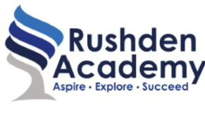

T

r

a

n

s

i

t

i

o

n

T

a

s

k